To find the requirement description for each uncompleted requirement log into your TEACH account and go to “Account Information”
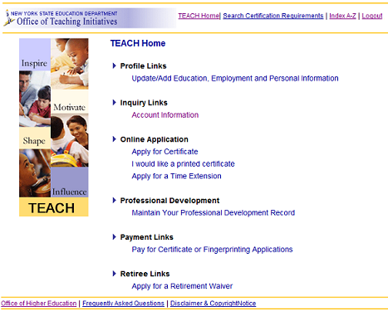
Click on Certificates then Click GO
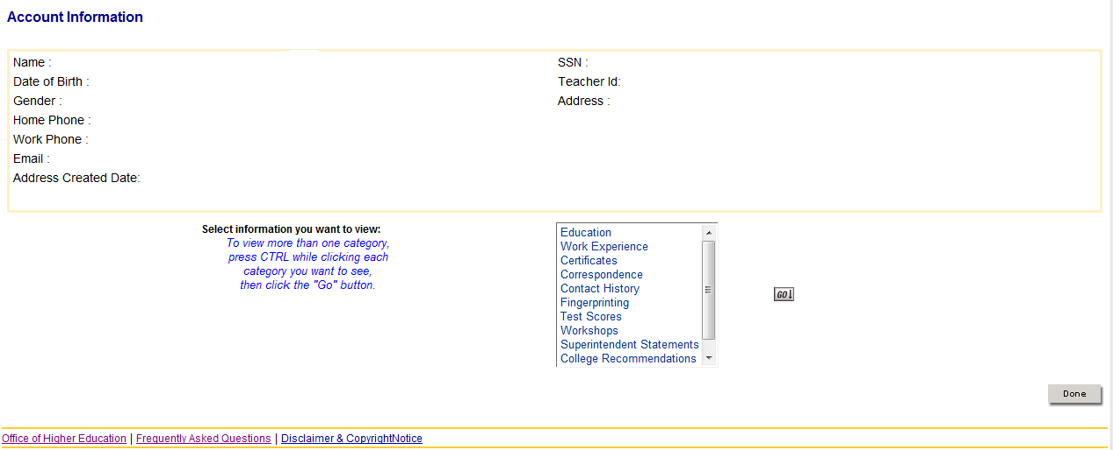
Your certificates tables will appear 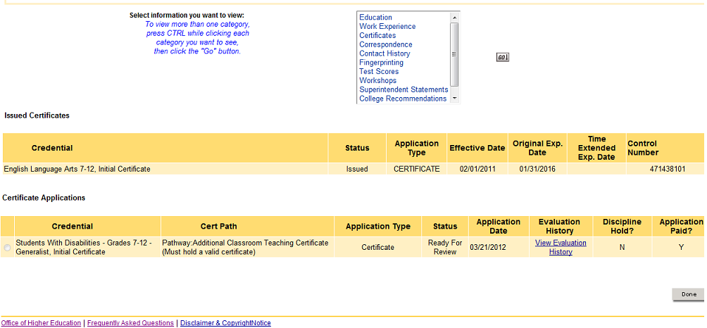
Click on “View Evaluation History”
The evaluation History for that certificate will open in a new window
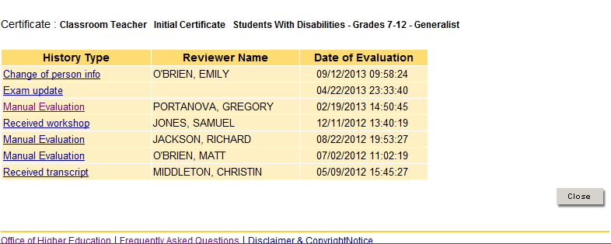
Click on the “Manual Evaluation” link to open the evaluation for the certificate
The evaluation will open in a new window. To determine what requirements are not met, look for Unmet or Deficient in the Current Status column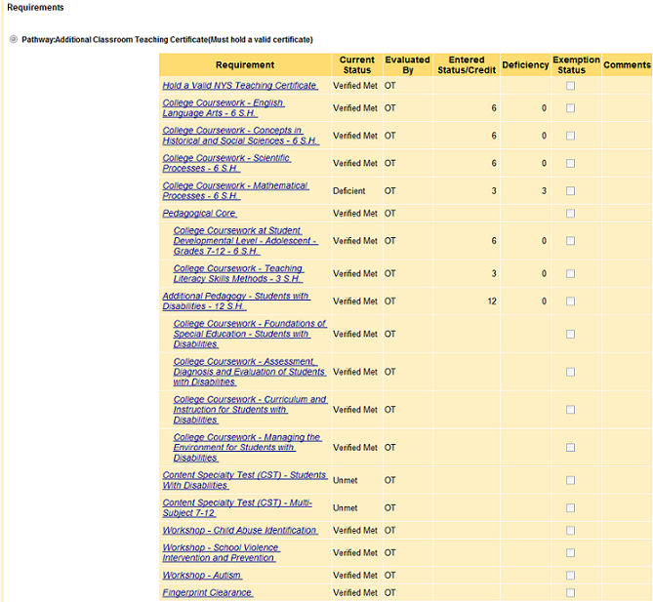
When you select a requirement and click on the link, a new window will open with the description of the requirement. In this case we clicked on College Coursework – Mathematical Processed – 6 S.H.



